Teenage Workshops
Deanne Newland
Artistic Soul Studio
http://www.deannenewland.com/

“The more I paint the more I like everything”
Jean-Michel Basquiat

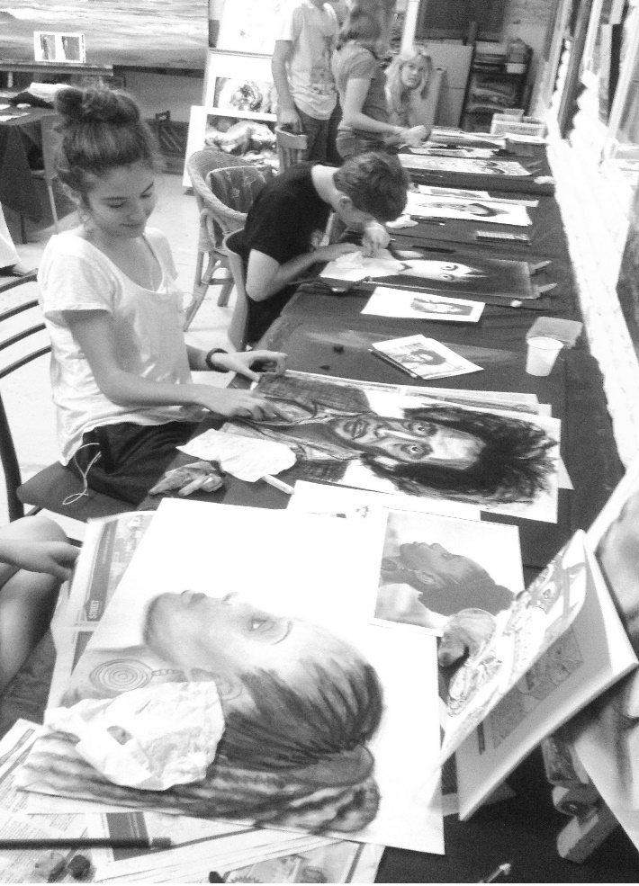
Deanne Newland is a contemporary artist, tutor and owner of The Artistic Studio Art School. Deanne's lifelong passion of art led to acquiring a Bachelor of Fine Arts & Diploma in Education, which upon completion taught high school students visual arts for several years. Deanne ceased teaching in 2009 to open The Artistic Soul Studio.

The Artistic Soul Studio is a space for teenagers to disconnect from electronic media, academic and social expectations to relax and just be themselves.

Tuition given by Deanne will assist the skilled art focused students with their artistic capabilities while giving all time to be creative and express their emotions and thoughts.

The true meaning of their expression may never be articulated, but the act of expression and having the creative outlet is cathartic and of great benefit.

Students are in control of their creative self and process and interpretation of their work. This builds confidence and self-esteem in the knowledge that with diligence they can and will create works of art that are worthy of praise by anyone’s standards.

Workshop Details

When: Monthly Mon, Tue, Wed, Fri (NSW school terms)
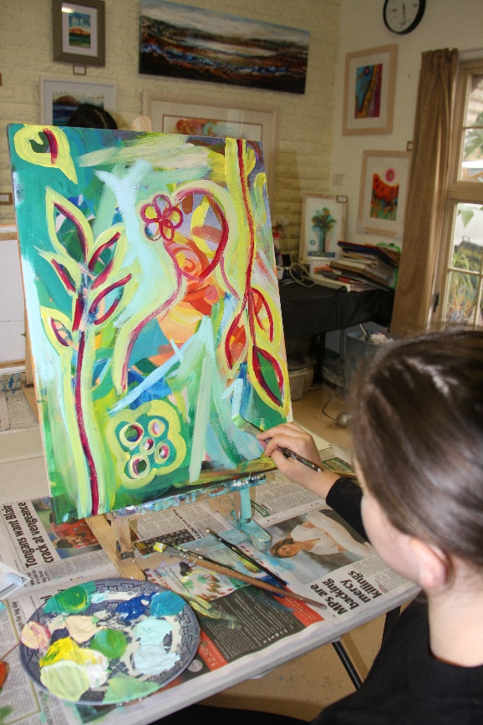
Time: 4pm till 6pm
Venue: Artistic Soul Studio,
1 Parbury Place, Swansea Heads
Cost: $28

Included in cost:
- Tuition
- All materials
- Afternoon tea
What to bring:
- An apron or old/painting clothes

Special Requirements:
New students: Please ensure you bring a signed copy of consent (page 3)
Bookings and Payment
Contact Deanne to book you place and arrange payment.
Phone: 0419441200
Email: artisticsoul.newland81@gmail.com

Notes: Teen workshops are grouped into the following categories: years (7,8,9) &
Years’ (10,11,12). These categories are a guide so similar aged/skilled teens are together. The groupings are flexible to allow siblings to attend the same class or other possible scenarios.

Workshop days can be viewed on Deanne’s website under the calendar menu http://www.deannenewland.com/
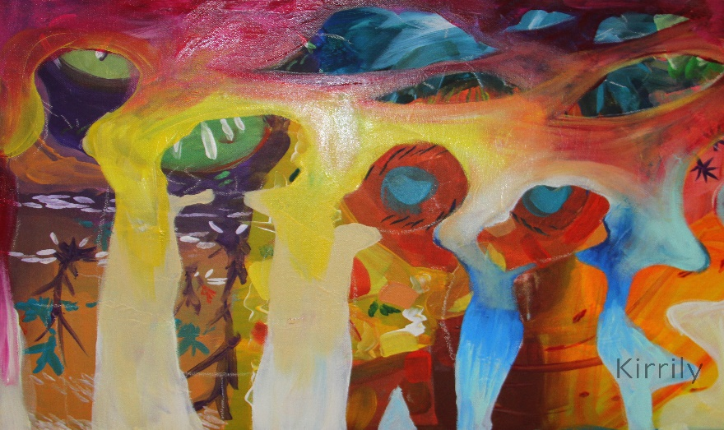

Teen Workshops with Deanne Newland
Artistic Soul Studio

Name of Student:____________________________________________________ Age ________

Parent/Guardian Name _____________________________________________________________

Email Address ____________________________________________________________________

Address: _________________________________________________________________________

_________________________________________________________________________________

Parent Mobile: _________________________ Student Mobile: ____________________________

Does your child have any allergies, medical conditions (asthma etc..) or food allergies?

_________________________________________________________________________________

_________________________________________________________________________________

_________________________________________________________________________________

_________________________________________________________________________________

I give permission for my child to be photographed with their artworks that may be used in promotional fliers or on my website.

(Please circle) YES / NO

In the art workshop your child will be using paints, inks, clay, scissors, glue and various drawing equipment. Please sign below to give permission for use of this equipment.

________________________________________________________

