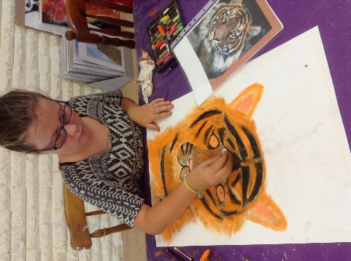
January – Kids/Teenagers Art Workshop at The Artistic Soul Art Studio
Art Tutor:
Deanne Newland (Bachelor of Visual Arts and Diploma in Education)
www.deannenewland.com
0419441200
1 Parbury Place, Swansea Heads, 2281 NSW
Full payment will be required one week before the workshop date in advance to reserve their spot. You can book on-line and pay via PayPal or contact Deanne via email or text message to arrange other methods of payment.
Maximum in each class is 7 students

Create a Clay Dog or Cat
Date: Tuesday 9th January,
Time: 9am till 12noon,
Wear old clothes,
All art materials supplied & morning Tea
Cost: $38 per student.
The students will create a three -dimensional dog or cat using clay. The students will learn how to create a three- dimensional shape and develop their clay building techniques. These can be taken home after the session.

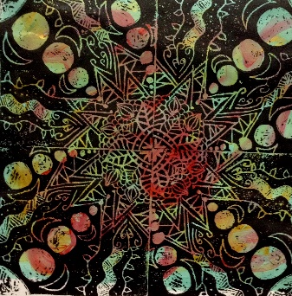
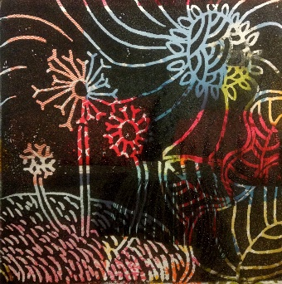
Printmaking
Date: Friday 12th January ,
Time: 9am till 12 noon,
Wear old clothes,
All art materials supplied & morning tea,
Cost: $38 per student.
The students will create an edition of prints (5) and explore lino printing techniques. These artworks can be taken home at the end of the session.

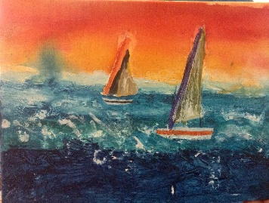
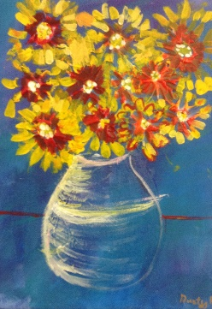
Mixed Media painting
Date: Tuesday 16th January,
Time: 9am till 12 noon,
Wear old clothes,
All art materials supplied & morning tea,
Cost: $38 per student.
The Students will create a mixed media artwork on canvas. They will use impasto medium and acrylic paints. They will explore various painting techniques. This can be taken home after the session.

Learn how to Draw a face
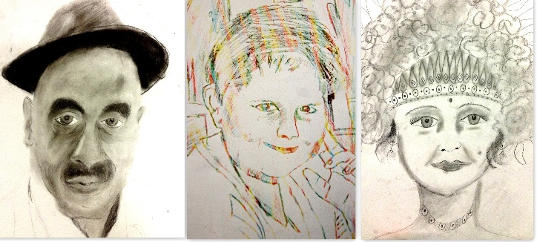
Date: Friday 19th January,
Time: 9am till 12 noon,
Wear old clothes,
All art materials supplied & morning tea,
Cost: $38 per student.
The students will be taught technical aspects of drawing a face and how to capture an expression. They will also develop their understanding of tone and texture. The students will create several portraits throughout the three hours. The artwork can be taken home after the session.

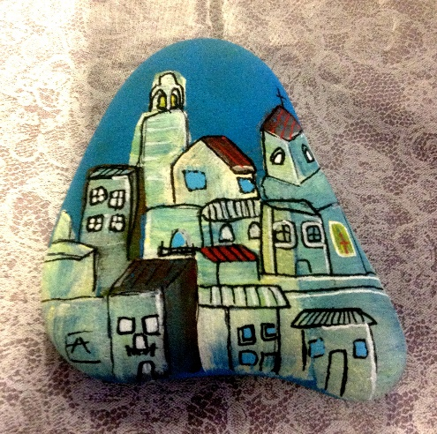
Rock Painting
Date: Tuesday 23rd January,
Time: 9am till 12 noon,
Wear old clothes,
All art materials supplied & morning tea,
Cost: $38 per student.
The students will create a painting onto rock surfaces developing their painting and colour mixing skills. They will produce two painted rocks to take home on the day.

