LETS PAINT FRIDA KAHLO
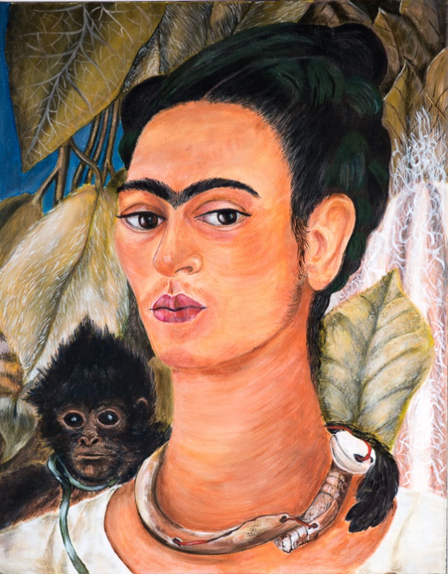
With Deanne Newland “I paint flowers so they will not die.” ― Frida Kahlo
Frida Kahlo 1907 - 1954
Frida Kahlo is a Mexican Artist. Her auto-biographical paintings were before their time. She is one of the most adored artists of our century. Her art and life story influenced generations of artists.
When she was young she was in a bus/Tram accident that defined her life and art. Whilst recovering from her injuries (which caused her to be bed ridden), she began to paint.
She was married to a famous Mexican Mural artist called Diego Rivera and is best known for her self portraits.
Today she is a national treasure in Mexico, an icon throughout the world and one of my favourite artists.
Frida. By one of my amazing art students- Jan Daniels
This is a fun workshop. You will learn how to paint a portrait, capture a likeness, mix colours, create a good composition and develop your painting techniques. You may choose any style you like to capture your version of Frida Kahlo. Some examples are: Palette knife, cartoon, naïve, cubism, pop art, stylized, semi-abstract etc. Your portrait may not be a realistic portrayal of Frida, but it could morph into looking like Frida’s sister, aunty, mother, nana, younger Frida, older Frida etc. In the end it doesn’t matter as long as you have enjoyed the process and experience and someone might say “Hey that artwork reminds me of that famous Mexican artist Frida Kahlo”.
Date: Saturday the 20^{th of} January 2018 -10am till 3pm
Location: 1 Parbury Place, Swansea Heads Cost: $65
Limit 8 students
Includes: Lunch, morning tea, glass of wine, Frida images & drawing materials,
What to bring: Apron, Brushes, Acrylic paints. (make sure you have a flesh colour and white), Canvas (size your choice).

The only thing I know is that I paint because I need to, and I paint whatever passes through my head without any other consideration -Frida Kahlo
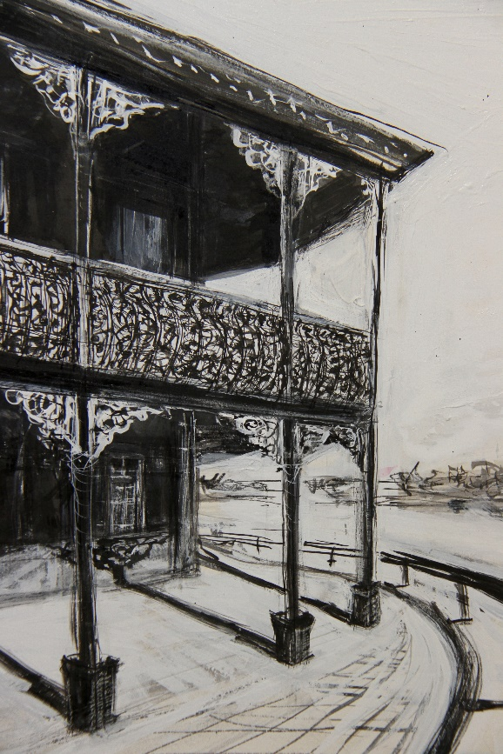
Learning to Draw for beginners
With Deanne Newland
Bachelor of Visual Arts and Diploma in Education
This will be a relaxed and enjoyable workshop where you will be taught the basics of drawing.
During this course you will learn:
- Using different types of drawing mediums- Pencil sketching, charcoal sketching, pen and ink and felt tip pen drawing,
- The importance of Line, texture, tone, contrast, shape, form & composition,
- Learn perspective,
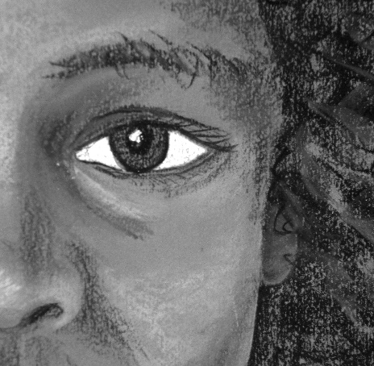
- Drawing the human form and faces,
- Drawing objects- Still life,
- Drawing landscapes and trees,
- The fundamentals of drawing:

Date : Saturday the 24th February.
Time: 10am till 3pm.
Included : morning tea/coffee, all drawing materials, lunch, Glass of wine/ soft drink.
Cost: $100
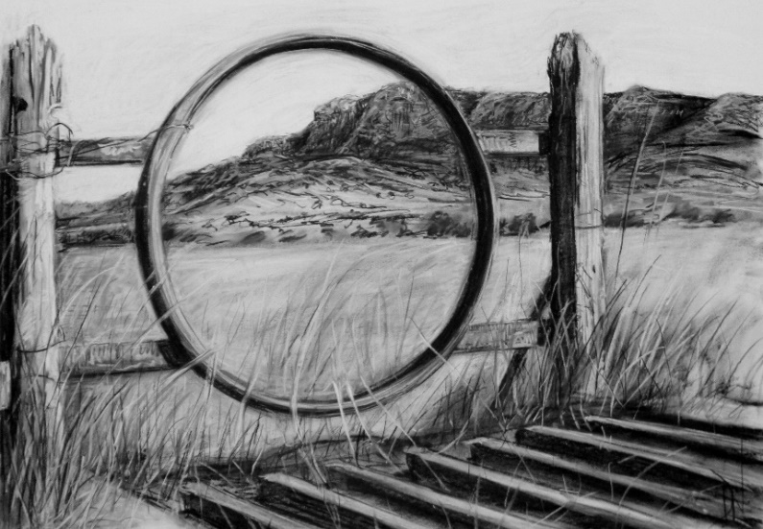
Venue: Artistic Soul Studio. 1 Parbury Place, Swansea Heads. 2281 NSW

